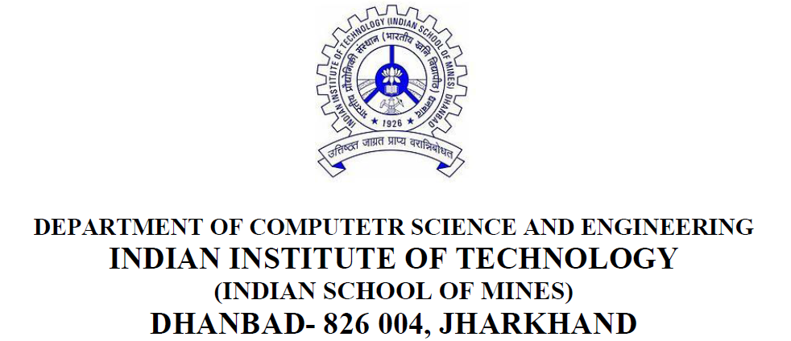

**Advanced DBMS Lab Manual**

**(Subject Code : CSC54202)**

***Submitted by -***

***Name : Nitish Bhattacharjee***

**(M.Tech, Second Year, Second Semester, Session 2017-2020)**

**Admission No. : 17KT000134**